Guided Writing Wheel
Allows students to experience success with writing and is learner centered and familiar.

Beginning Level:
- Student supplies subject.
- Tutor writes subject in hub of wheel.
- Tutor provides words or phrases (spokes).
I like music.
I like guitars.
I like writing songs.
I like singing.
I like dancing.
I like drawing.
I like tattoos.

- Student creates sentences from the wheel.
- Student reads sentences written.

Intermediate Level:
- Tutor chooses a topic word or phrase. (hub)
- Student supplies words about the topic.
- Tutor places words on spokes.
- Student uses wheel to create a story.
I like tattoos. They are beautiful works of art. Tattoos are words and pictures in ink on your skin. They are with you forever. Tattoos are reminders of things you don’t want to forget. Tattoos tell the world about you.
- Student reads story.

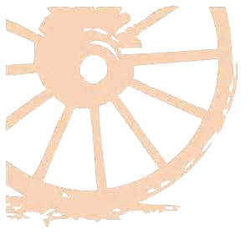
Guided Writing Wheel - Allows students to experience success with writing.

Advanced Level:
- Student supplies topic. (hub)
- Tutor or student organizes words and phrases on wheel
- Student creates story from wheel.
- Student reads the story.
My name is Cooper. I am 25 years old and I just got married. I work part-time as a kitchen helper. It is a hot, dirty job and it doesn’t pay much. I play music for money too. I want a better job but I need a High School diploma to get one. I quit school when I was 17. It was my junior year. I like writing lyrics and playing music. I enjoy drawing tattoos. A job doing either of these things would make me very happy.

